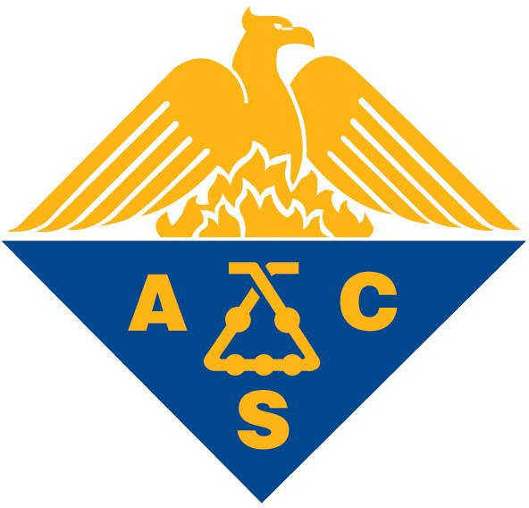
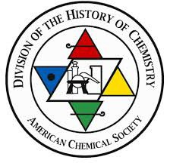

Meeting/Symposium/Conference Funding Request
ACS Division of the History of Chemistry

The Division of the History of Chemistry (HIST) recognizes the value of supporting the organization of symposia, conferences, or meetings that benefit the study and promotion of the history of chemistry. If you are organizing such an event and would like to request financial support (typically, $500 per half-day session), please submit this form to the Division’s Secretary-Treasurer, Dr. Vera Mainz (mainz@illinois.edu) no later than two weeks before the HIST Executive Committee meets to consider such requests (i.e., during the national ACS meetings in late March and late August). Most successful requests are submitted at least six months before the actual symposium or conference takes place. It should not be expected that late submissions will be considered.

Meeting/symposium/conference:

Date of event:

Location of event:

Organizer(s):

Affiliation(s):

E-mail(s):

Budget request ($):

Title and brief description of symposium, including the anticipated number of speakers and the likely number of sessions to accommodate those speakers (use additional pages if necessary):

